* **Establishes a load balancer among tow vpc’s**

**1.** First of all to create two vpc.

1. Services > networking & content delivery > vpc > create vpc > subnet > internet gateway > route table.

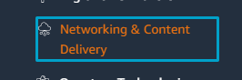







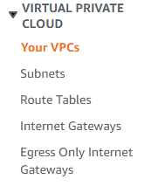



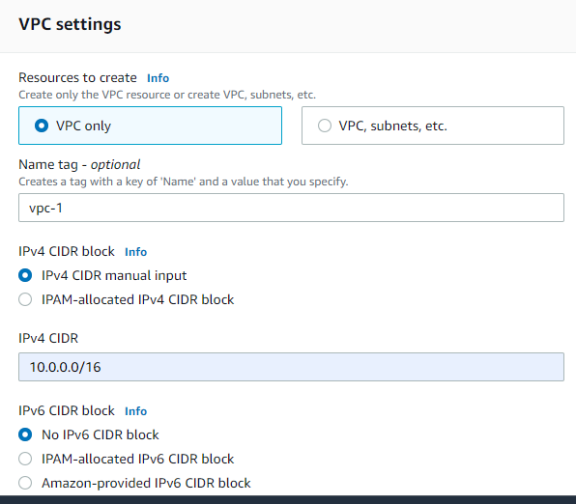

1. **Subnet**

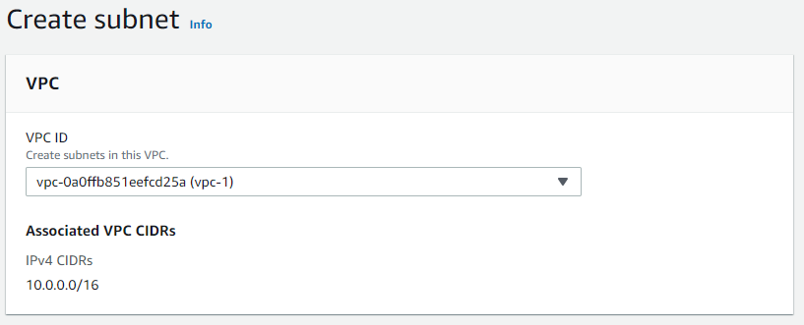



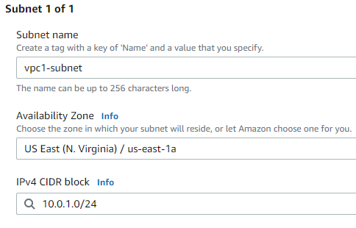



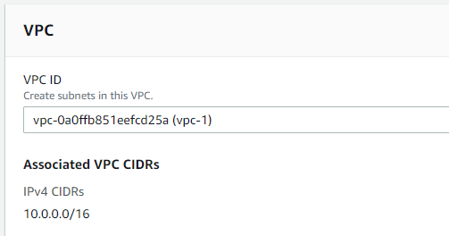



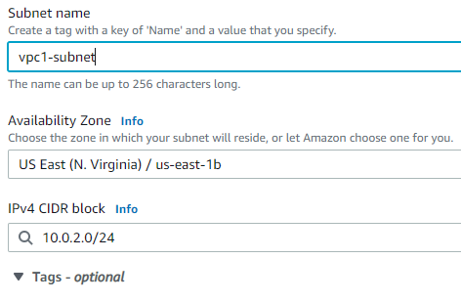



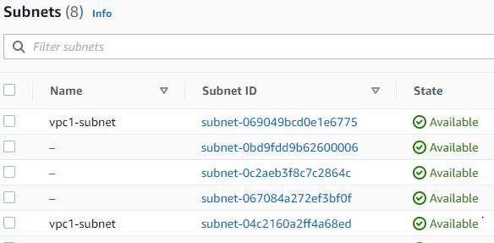

1. **Internet gateway**

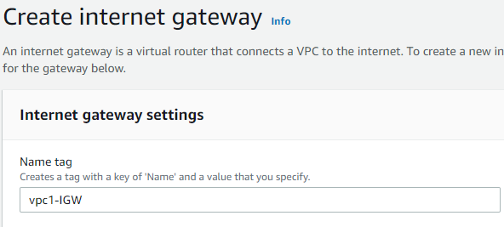



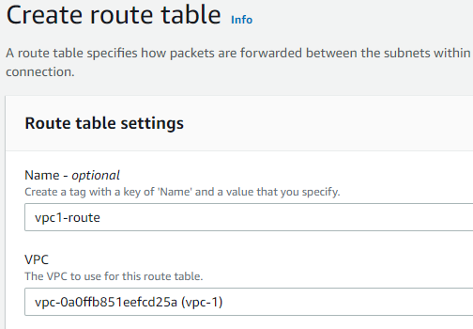



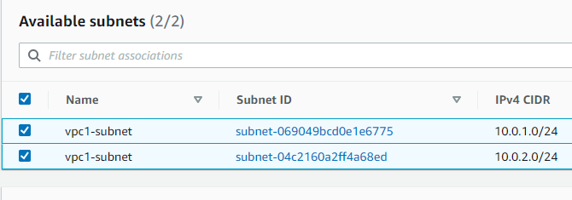



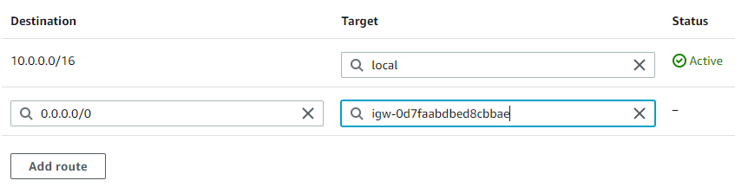

**1.1 creation of second vpc’s**

1. Vpc’s 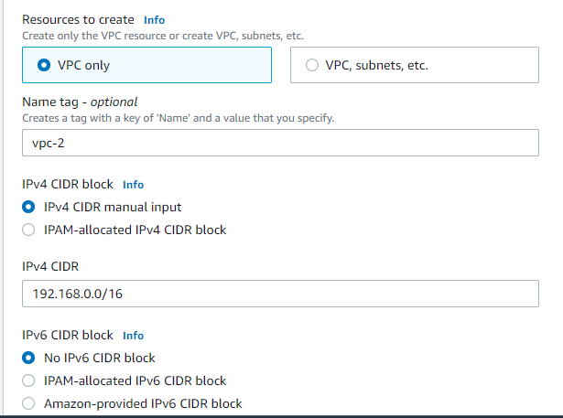

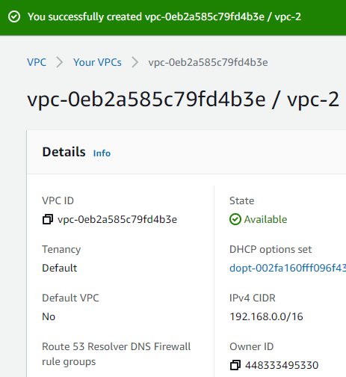

1. **Subnet**

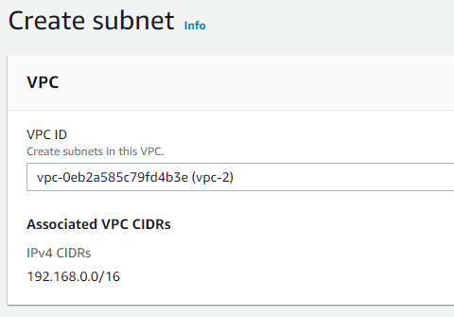



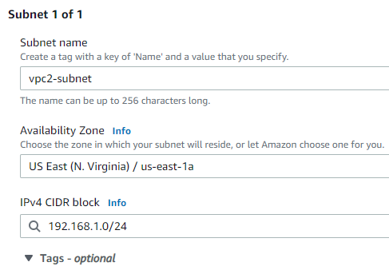

1. **Internet gateway**

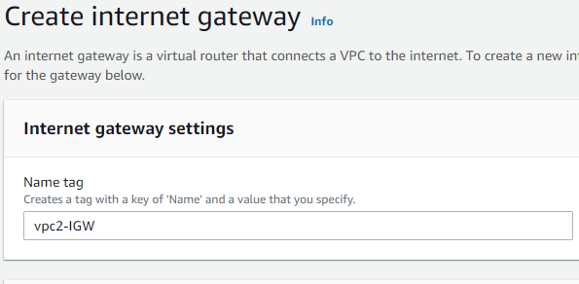



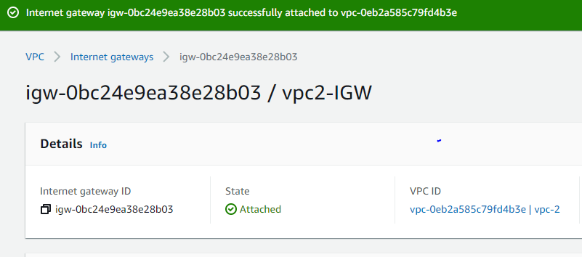

1. **Route table .**

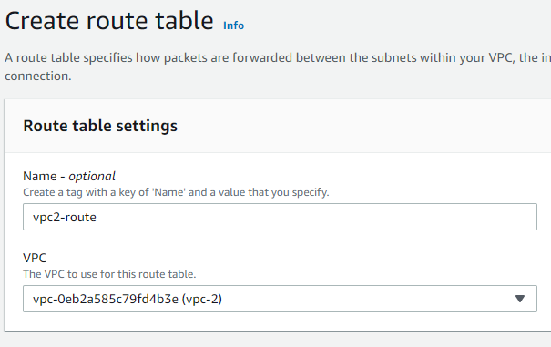



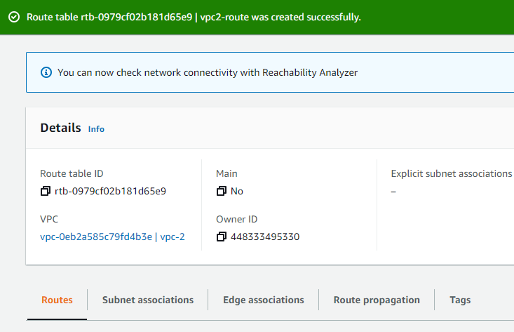

1. Associate route with the subnet

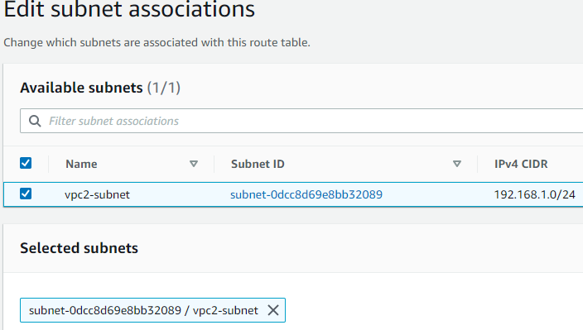

1. Edit the route and give direction to the internet gateway. Its ip is 0.0.0.0/0

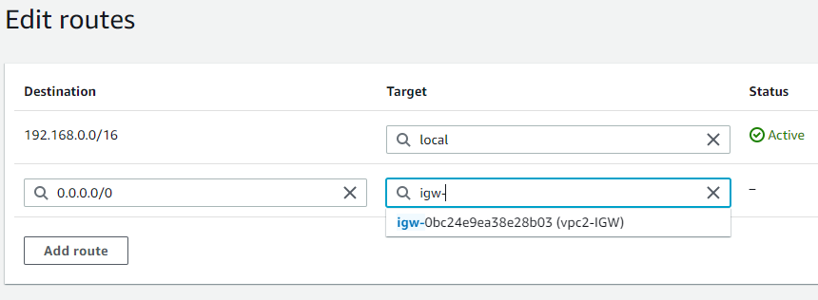

**1.2 Peering connection with vpc 1 to vpc 2**

* **Peering connection**
* A VPC peering connection is a networking connection between two VPCs that enables you to route traffic between them privately.
* Instances in either VPC can communicate with each other as if they are within the same network.

1. Service > ec2 > peering connection.

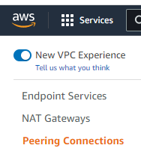

1. Creates peering connection to communication between vpc1 to vpc2.

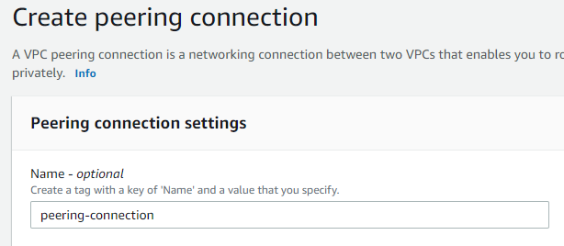

1. Requester vpc is ‘vpc1’

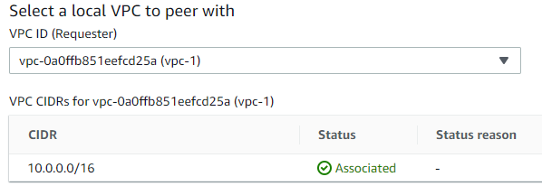

1. I can create for my account and another account and for same region and another region but i selected my account and for same region us-east-1.

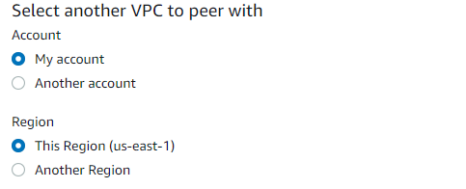

1. Accepter vpc id is ‘vpc2a’.

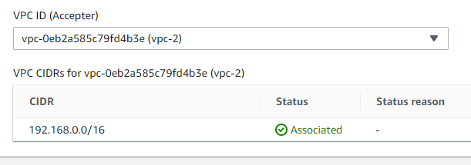



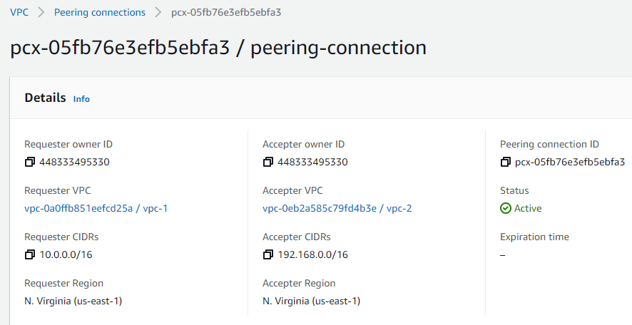

1. Give destination route table to connect peering connection with route 1 and route 2

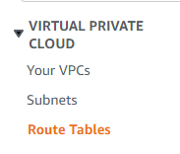

1. Route 1



1. Main route of vpc 1 is 10.0.0.0/16 and destination is vpc2 192.168.0.0/16

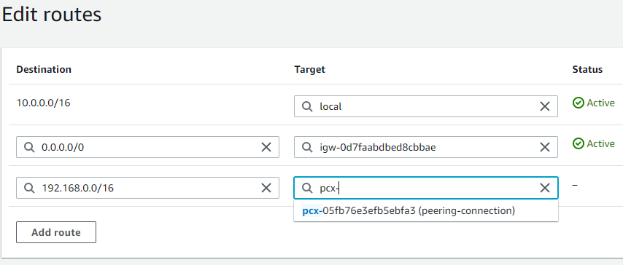

1. Route of vpc2.



1. For the vpc2 main route is 192.168.0.0/16 and destination is vpc1 CIDR is 10.0.0.0/16

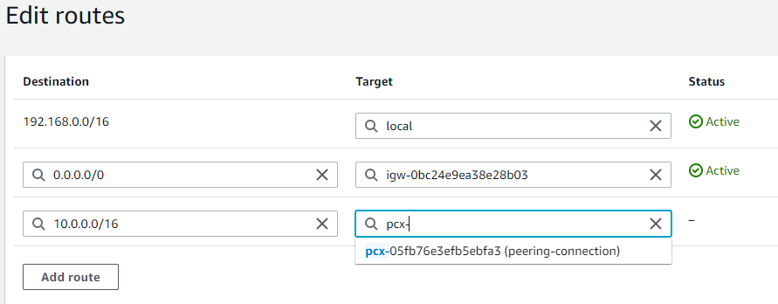

**1.3 Now i am going to create three instances.**

1. Service > ec2 > instances.

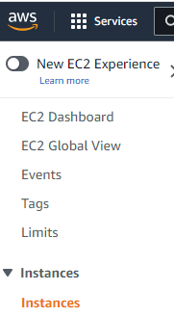



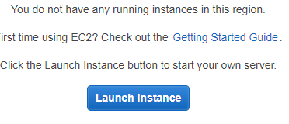

1. Microsoft windows server 2012 R2 base.



1. Instance type t2 micro this is a free tier eligible.





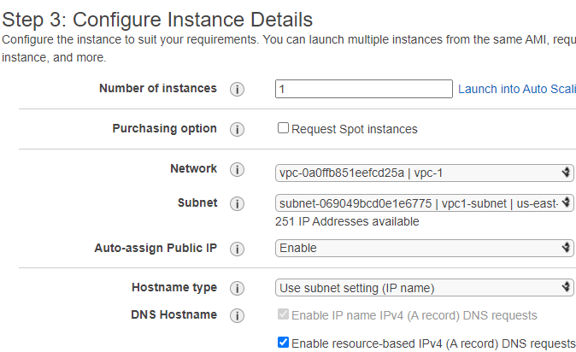



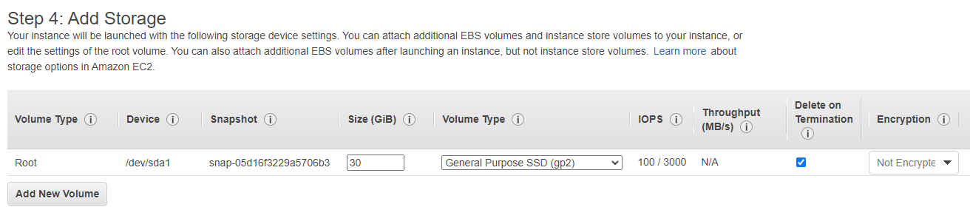



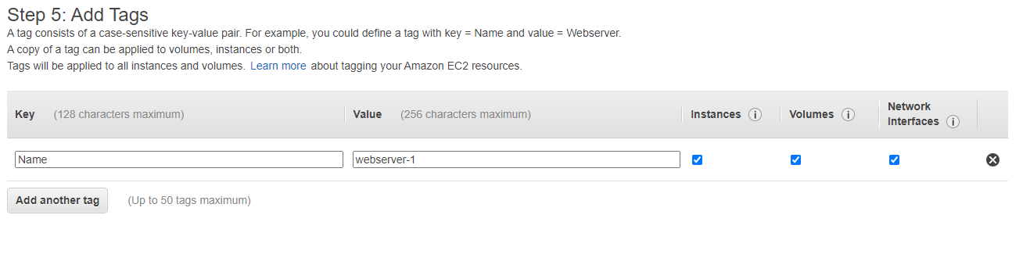

1. I select RDP,ICMP and HTTP rules source anywhere so as to access from any where via internet.

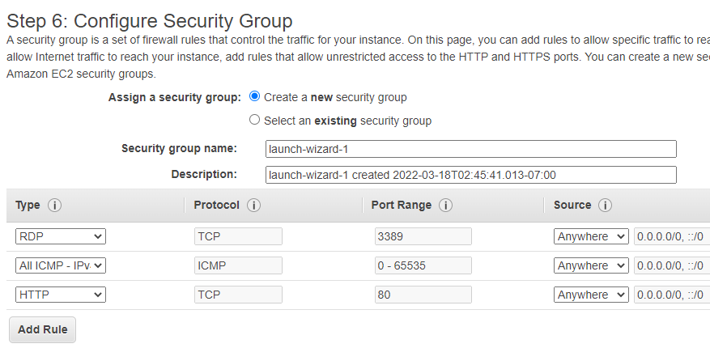



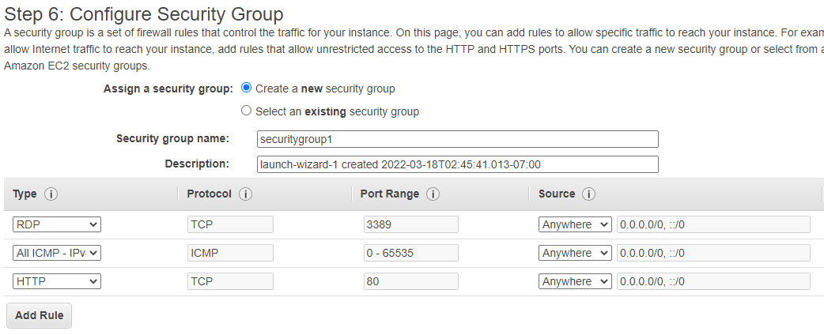

1. I create keypair name as server1-keypair

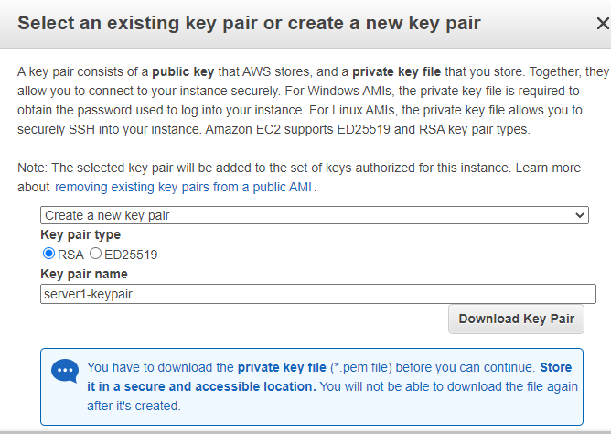

1. Creation of instance is successfully done

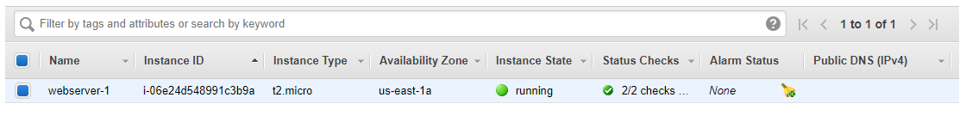

1. Now i take RDP

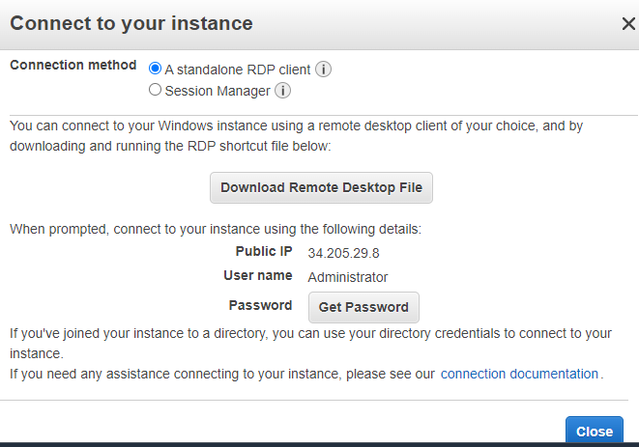



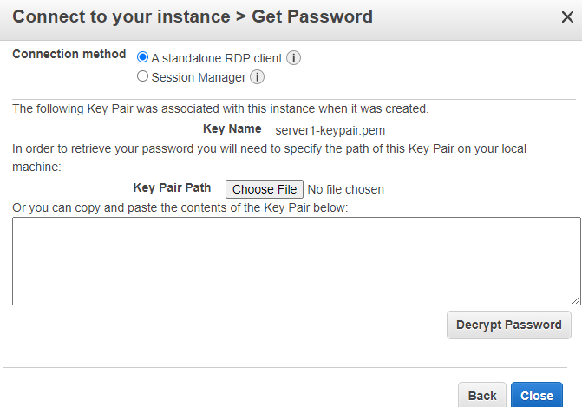



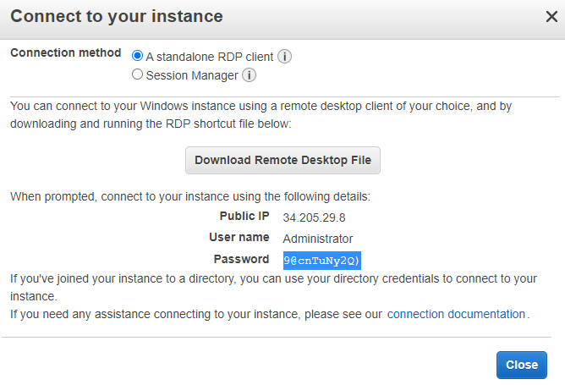



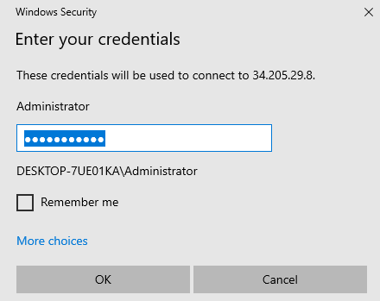

1. Instance 1 is connected with server

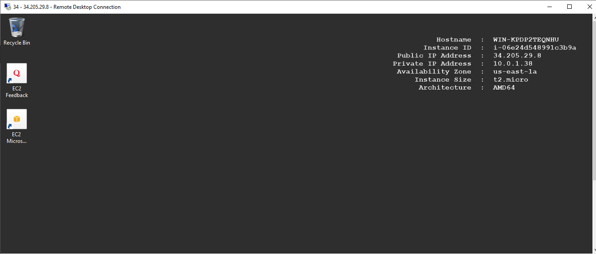

1. Now i am going to install webserver IIS.

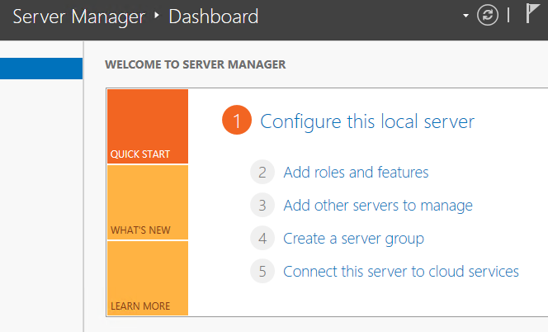



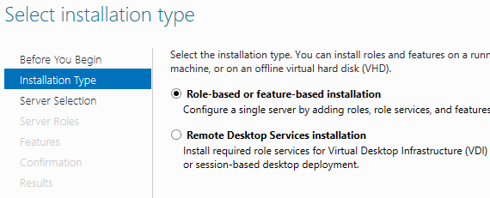



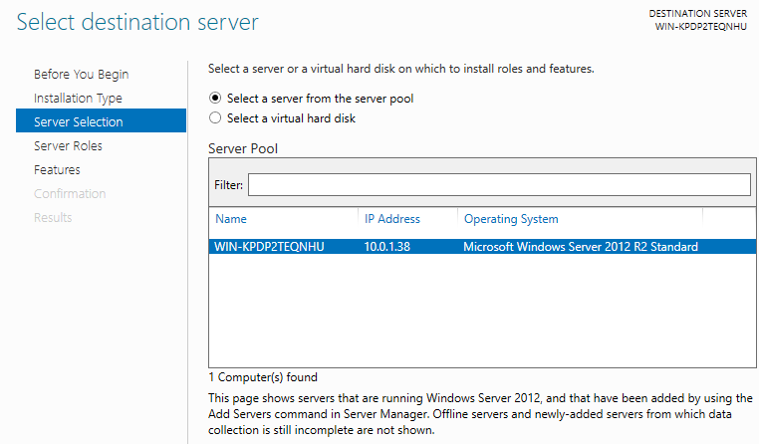



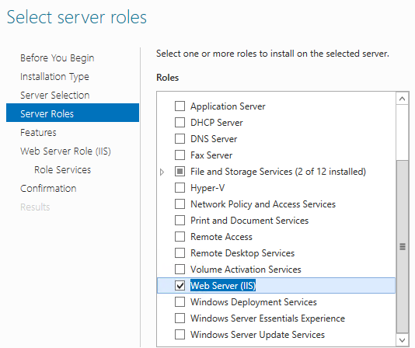



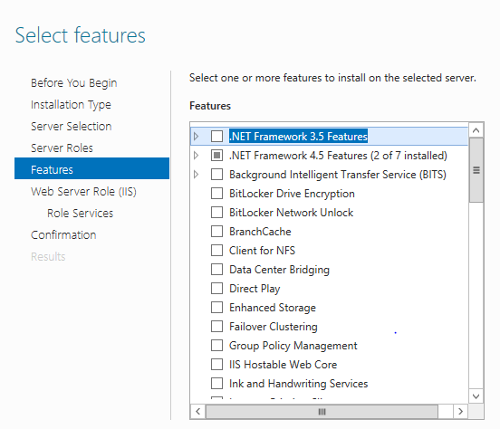



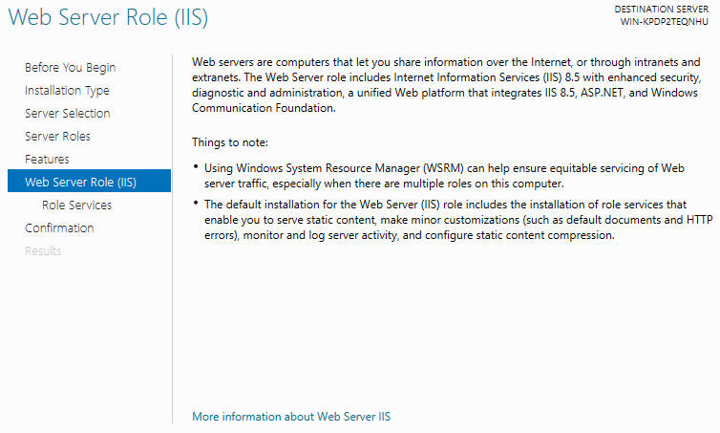



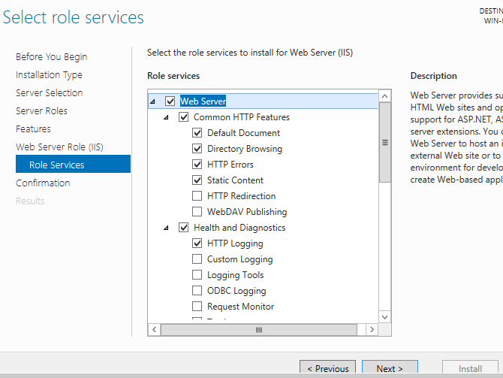



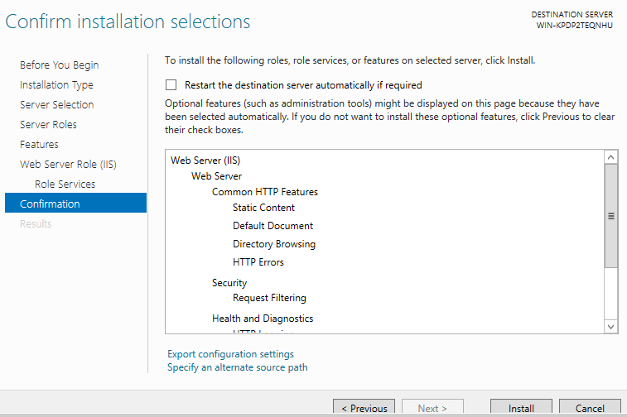



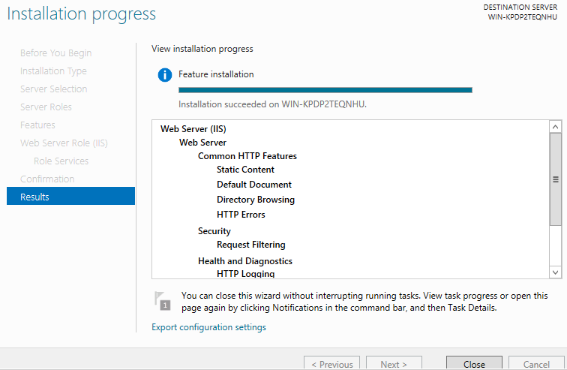

1. Now i am going to create webpage in root volume .

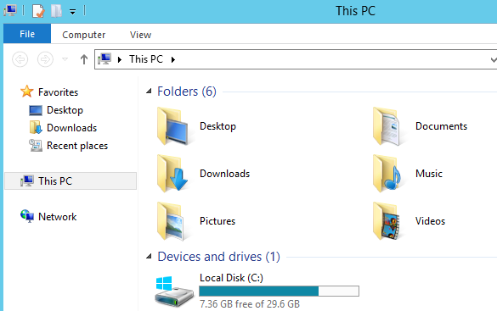











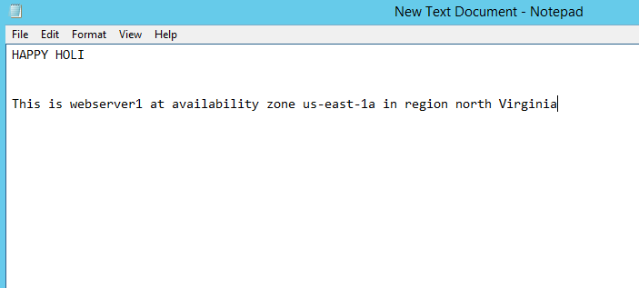



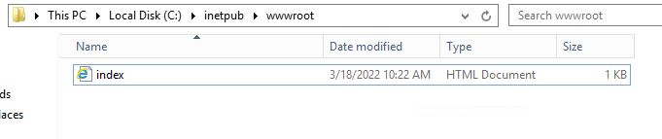

**1.4 2nd instance**



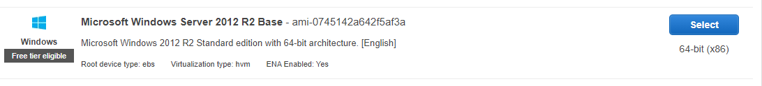







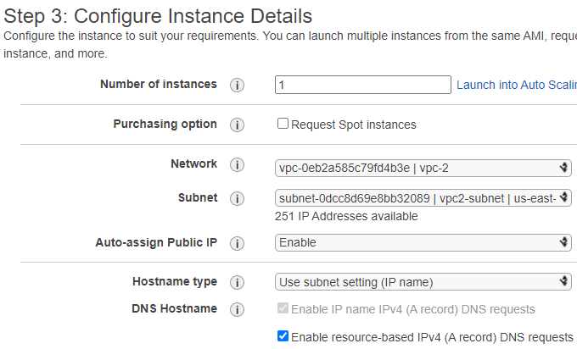



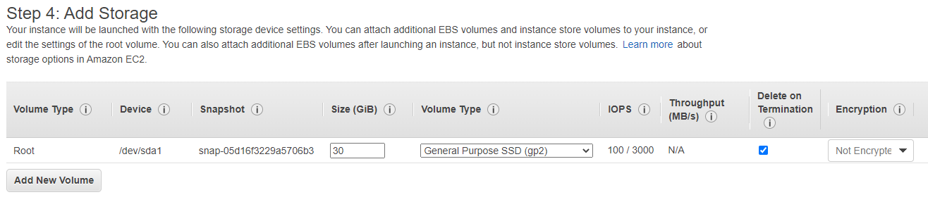



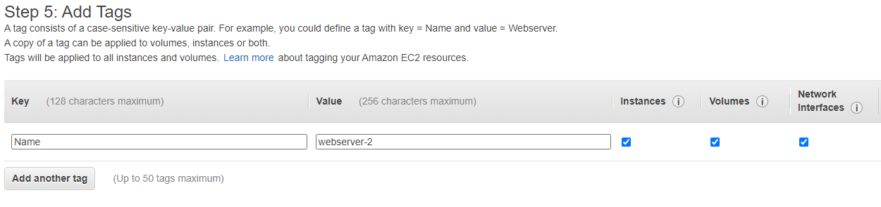



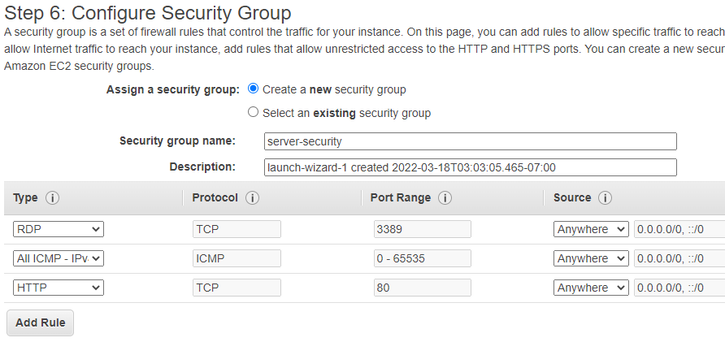



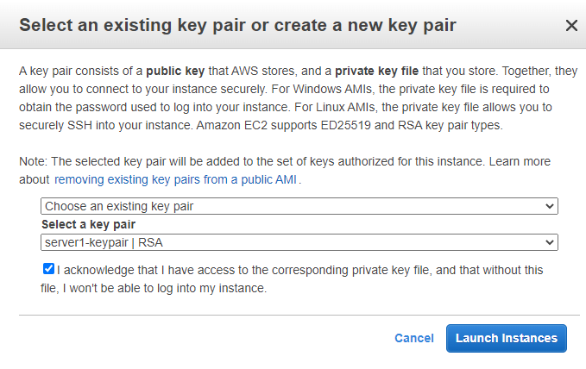



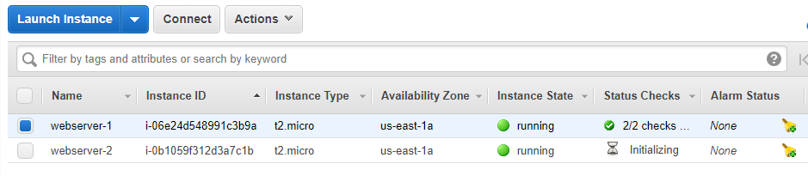



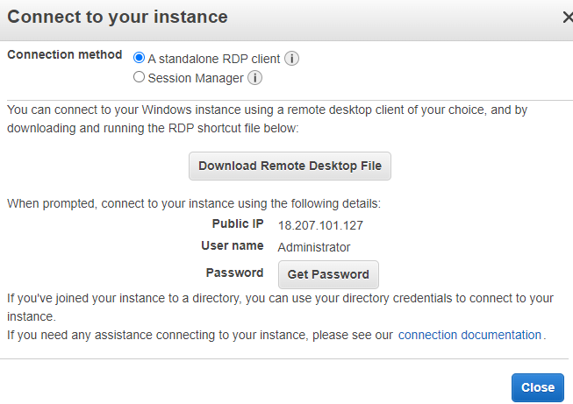



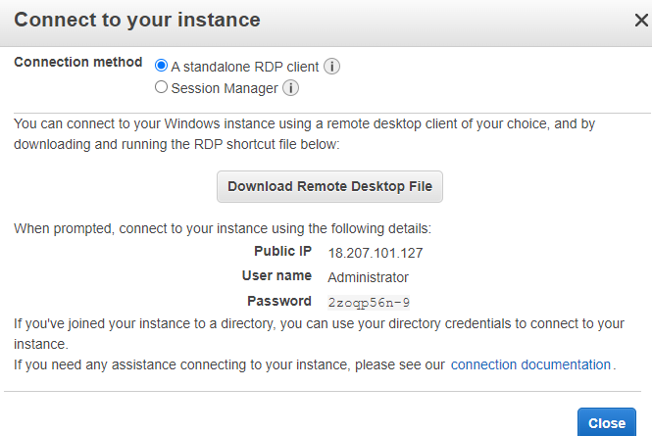



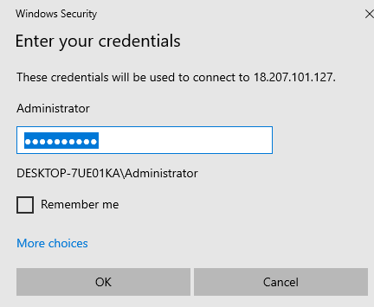



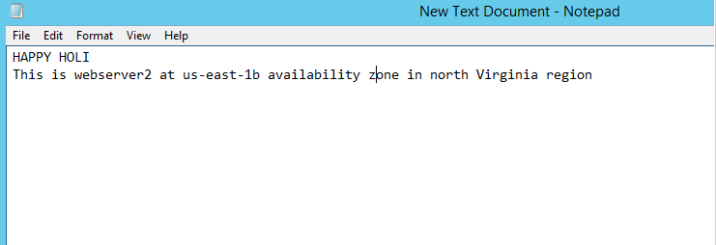

**1.5 3rd instance.**

















































**1.6 Elastic load balancer .**

1. 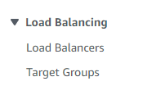



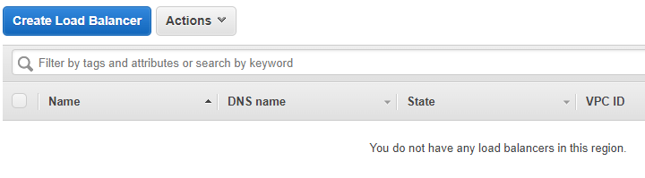



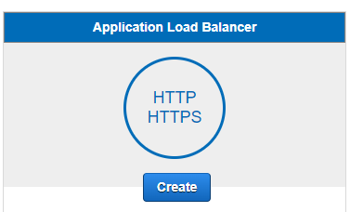



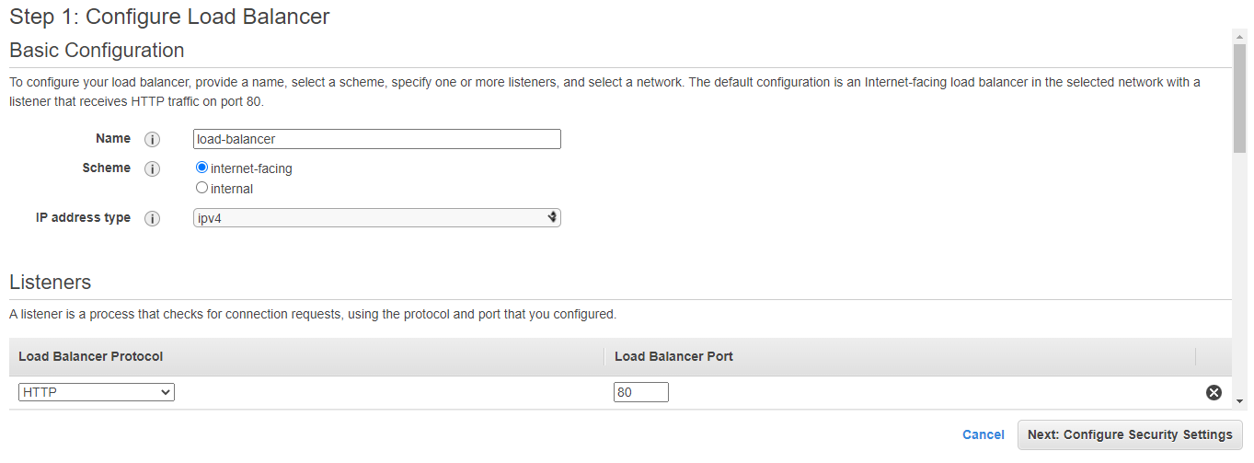



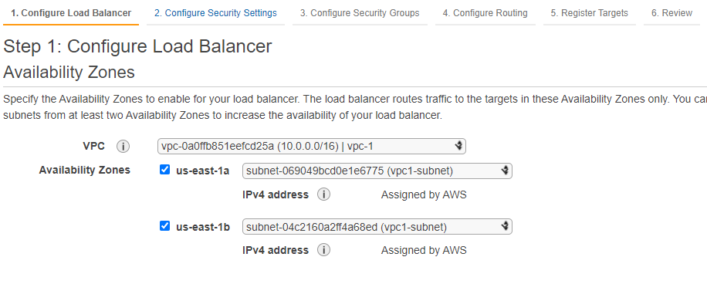



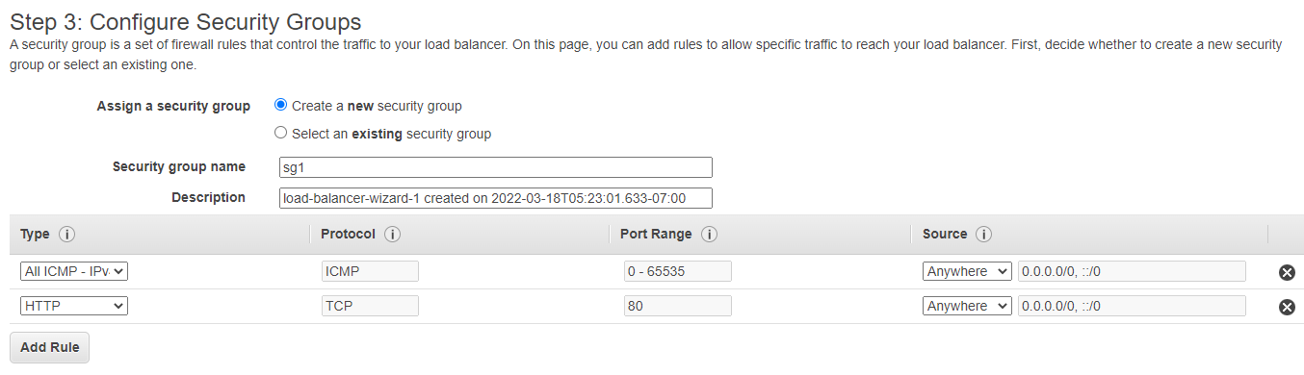



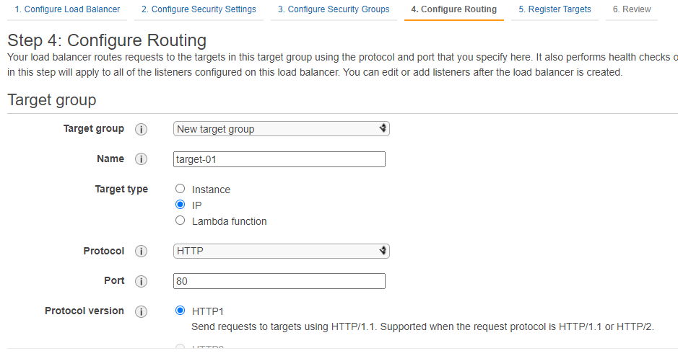



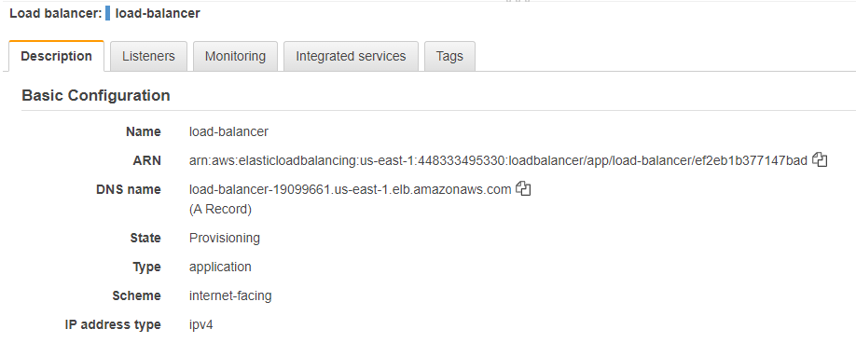



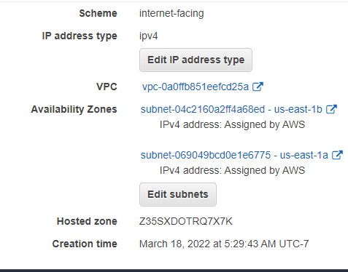



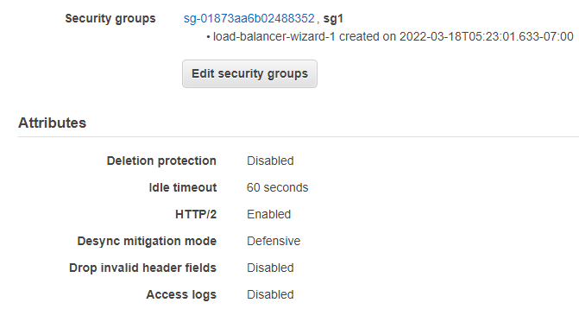



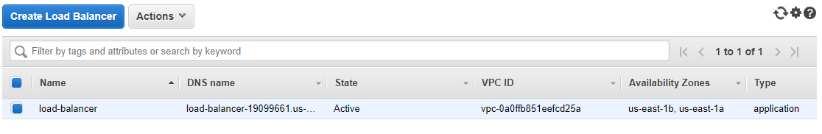

**1.7 Target group .**

1. It target group is IP address type .

* us-east-1a ip is 10.0.1.38
* us-east-1b ip is 192.168.1.36

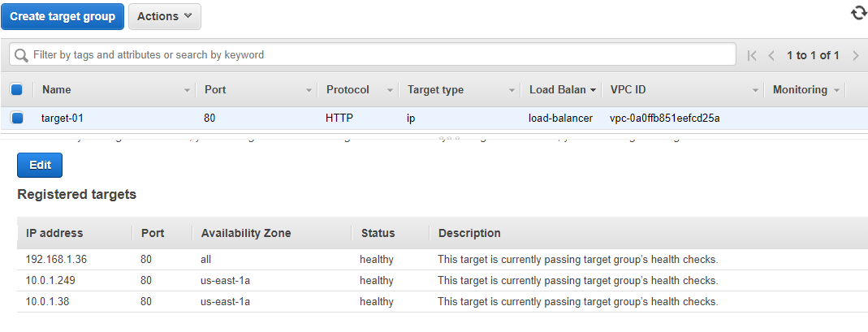



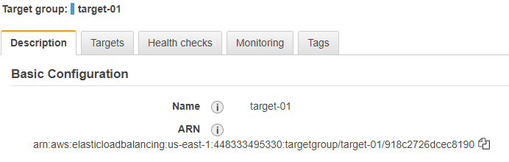



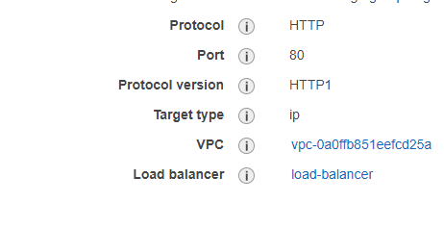



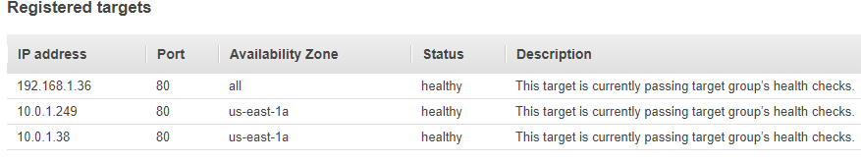

**1.8 copy DNS name and search in google.**

1. 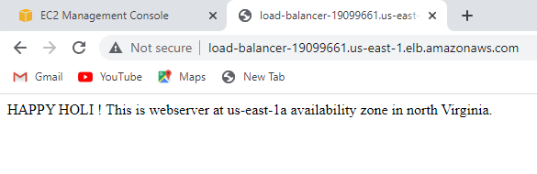

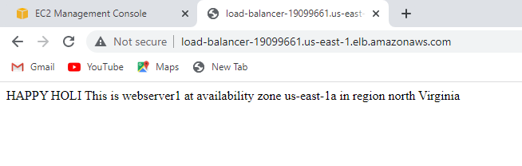

I did mistake to create webpage “webserver1 us-east-1b”

It perform elb sent the traffic at both availability zone us-east-1a and us-east-1b

**Summery**

1. tCreate two vpc
2. Create two subnets for both vpc
3. Create two internet gateway for both vpc
4. Create two route table for both internet gateway and add 0.0.0.0/0
5. Create peering connection update route.
6. Create three ec2 instances one each subnet.
7. Install webserver IIS and create webpage.
8. Create application load balancer
9. Create target group (target type IP)
10. Registered private ip’s of ec2 in target group.
11. Copy dns name of load balancer and search in web browser.